

Help and User Guide
Makhanda Connect System
Step-by-step guidance for residents, ward councillors, municipal staff, organisations and administrators
Version 1.0 | 2026
FIGURE1:M-LINK Landing or homepage image
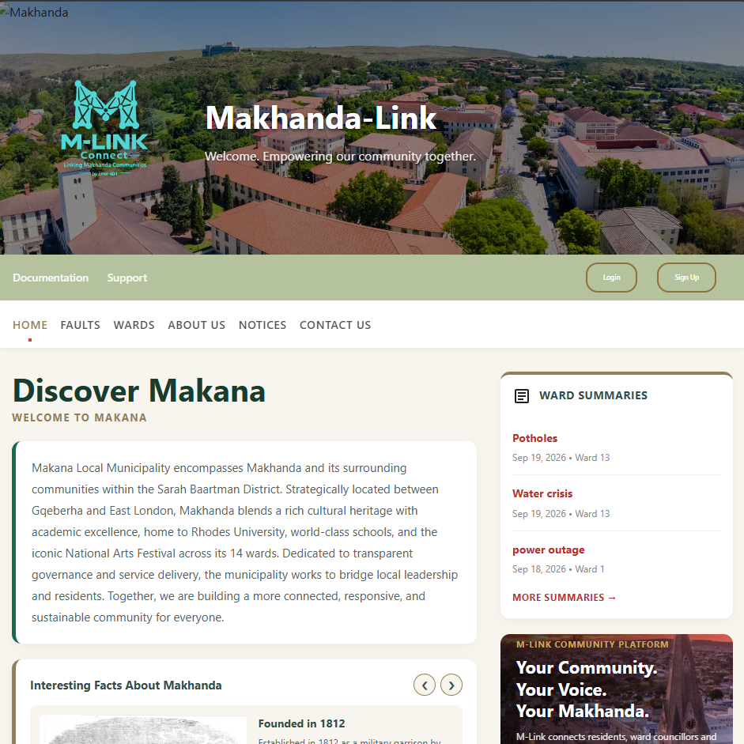
Figure 1: M-LINK cover or homepage image

1 Introduction
This guide explains how to use M-LINK, a web-based platform that connects Makana Municipality with residents, ward councillors, municipal staff and organisations. Follow the section for your role. The screenshots will show the exact buttons, forms and results described in each procedure.

1.1 Who should use this guide
- Residents who view community information and report service faults.
- Ward councilors who access ward-level information.
- Municipal staff/communication offier who manage assigned service-fault tickets.
- Organizations that register and access organisation functions.
- Administrators who manage accounts, wards, services, notices, tickets and reports.

1.2 Before you begin
Use a supported web browser and a stable internet connection. Keep your username and password private. Some roles must be verified and activated by an administrator before login is allowed.
M-LINK public homepage
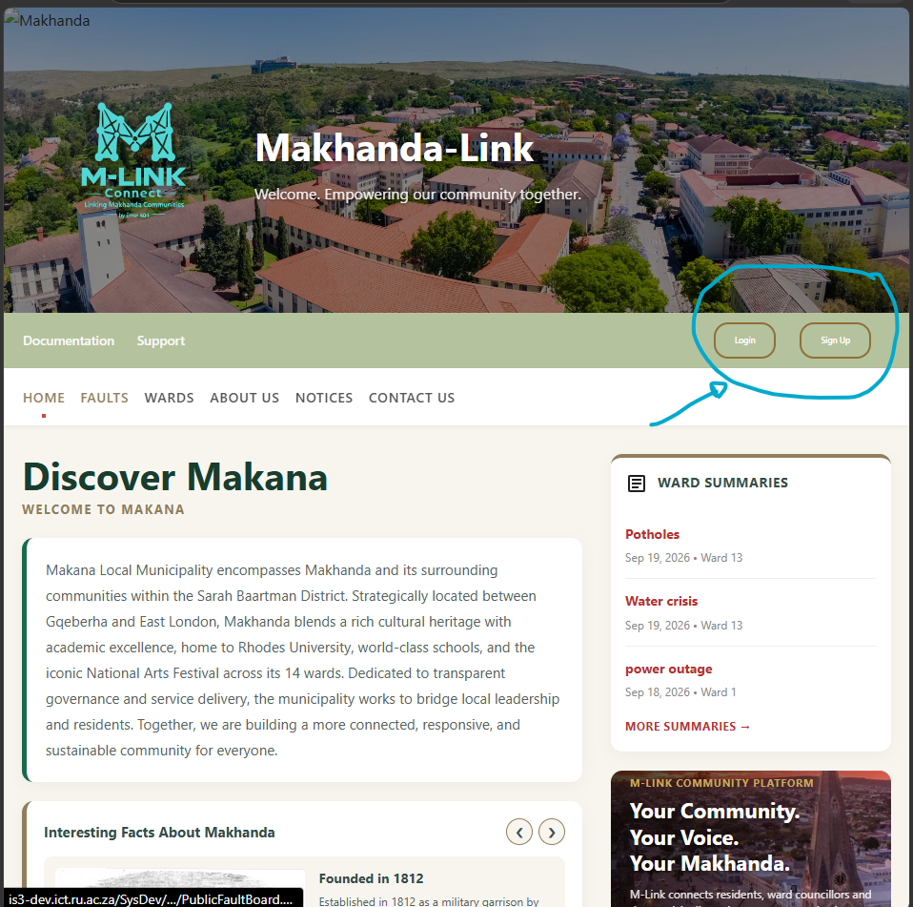
Figure 2: M-LINK public homepage

2 Getting Started

2.1 Open M-LINK
- Open your web browser.
- Enter the M-LINK web address.
- Wait for the public homepage to load.
- Use the homepage to view public notices, community information and more without logging in.

2.2 Register a personal account
- Select Sign Up on the homepage.
- Choose your user role: Resident, Organization, Ward Councilor or Municipal Staff.
- There is an exception for organization, they have their own separate form.
- When you click organization, you are automatically taken to the organization form.
- Enter your name, surname, email address, contact number, password.
- Select your street the system automatically fills the ward.
- Complete any role-specific fields shown on the form.
- Confirm your password and submit the registration form.
Expected result: Residents are registered for immediate use. Ward councillor and municipal staff accounts remain inactive until the required administrator process is completed.
Figure 3: Personal account registration
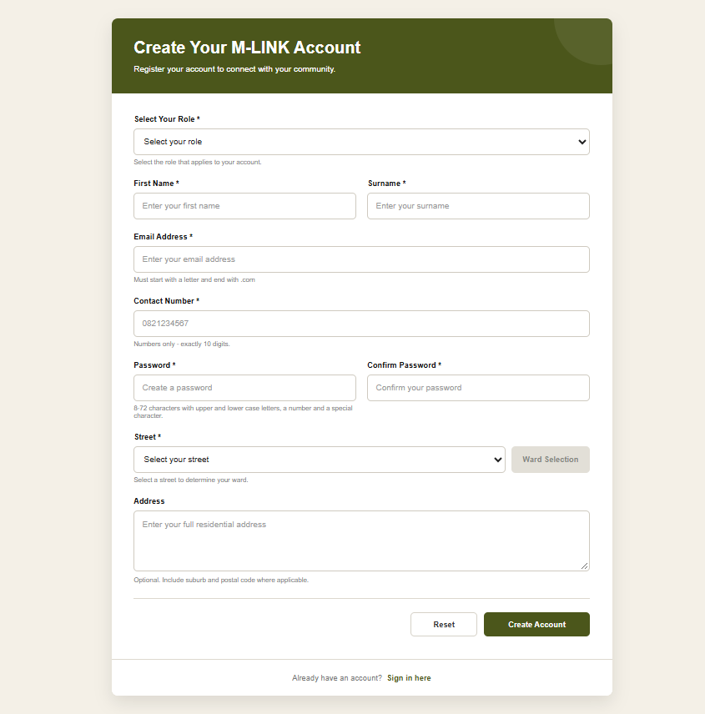

Figure 3: Personal account registration

2.3 Register an organisation
- Open the registration area and select Organisation.
- Enter the organisation name, email address and contact number.
- Select the organization street and automatically the system fill the ward.
- If you want to give your full address that is optional.
- Check the automatically displayed address, ward and postal code.
- Create and confirm the password.
- Submit the form.
Expected result: The organisation account is created and can proceed to login.
Figure 4: Organisation registration
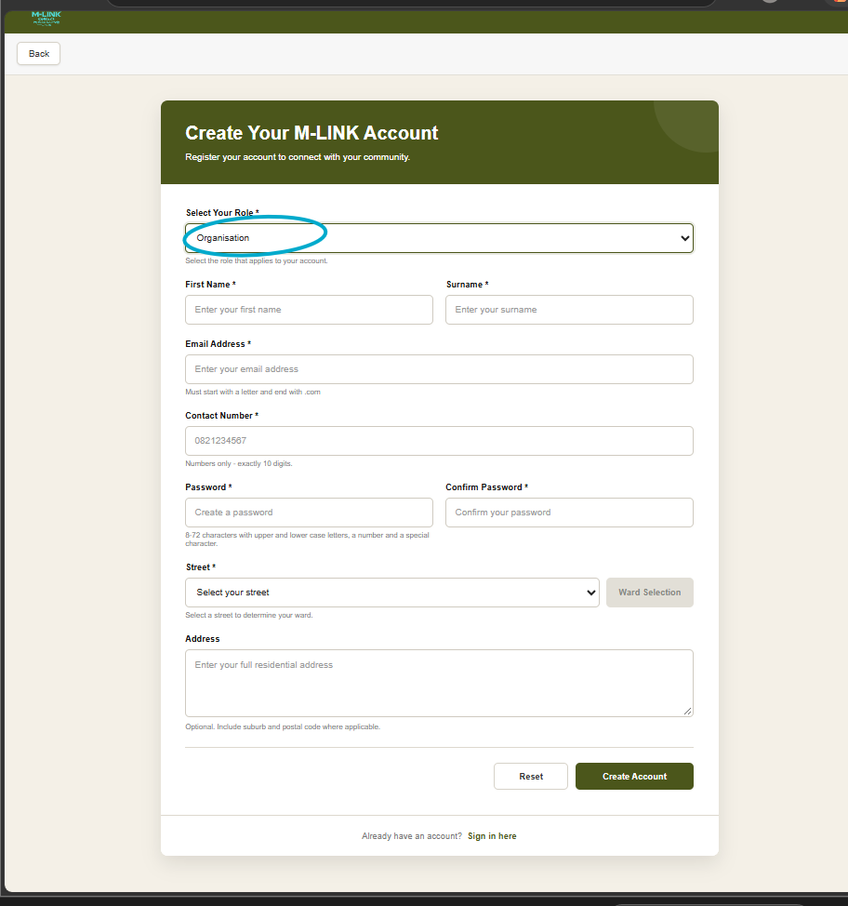
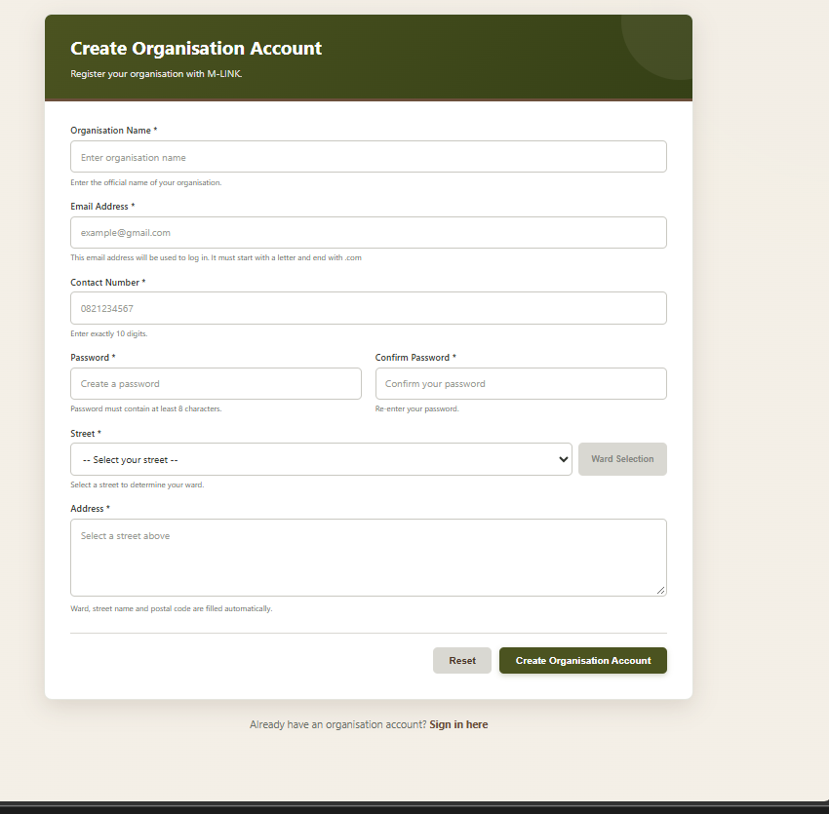
Figure 4: Organisation registration

2.4 Log in
- Select Login on the homepage.
- Enter the registered email address.
- Enter the password.
- Select Login.
- Wait for M-LINK to open the dashboard for your role.
Expected result: The correct role dashboard opens. If the account is inactive or unverified, M-LINK blocks access and displays a safe message.
Figure 5: Login page
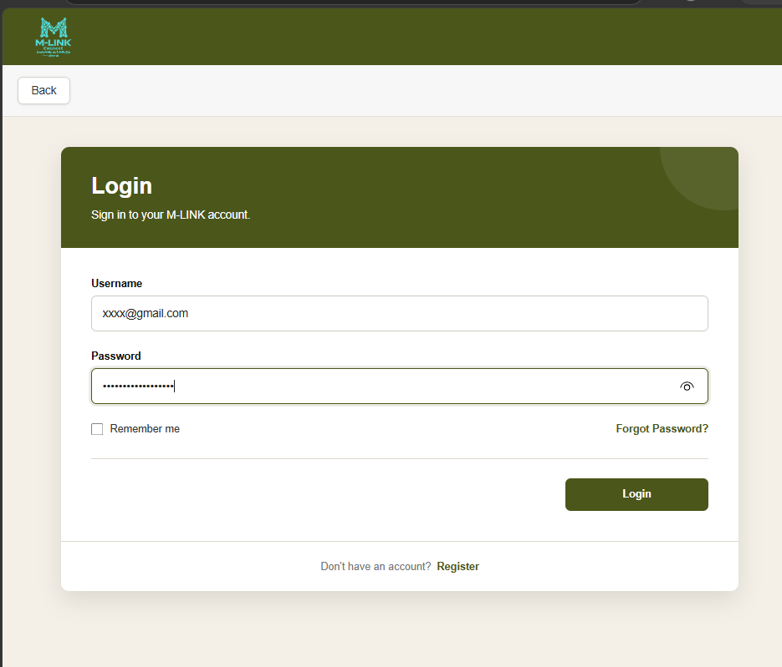
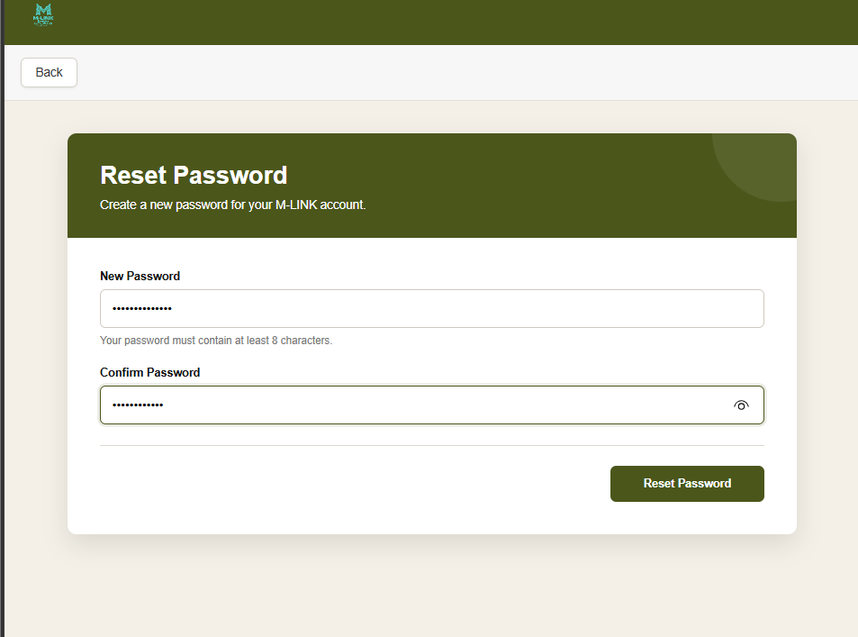

Figure 5: Login page

2.5 Reset a forgotten password
- Select Forgot Password on the login page.
- Enter the email address linked to the account.
- Request the six-digit one-time PIN.
- Enter the PIN before it expires.
- Create and confirm a new password.
- Return to login and use the new password.
Expected result: The password is updated after successful PIN verification.
Figure 6: Password reset flow
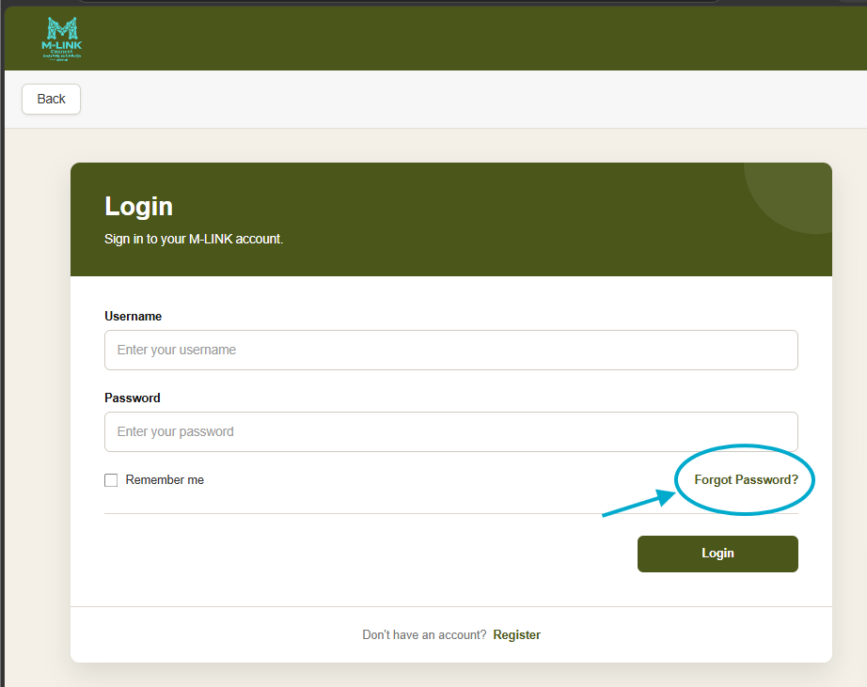
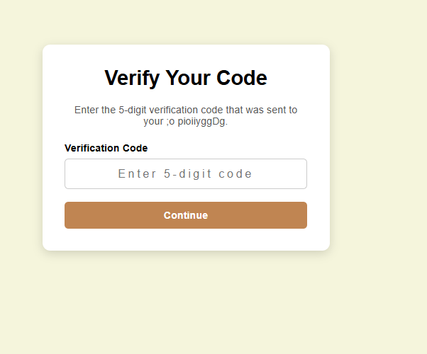
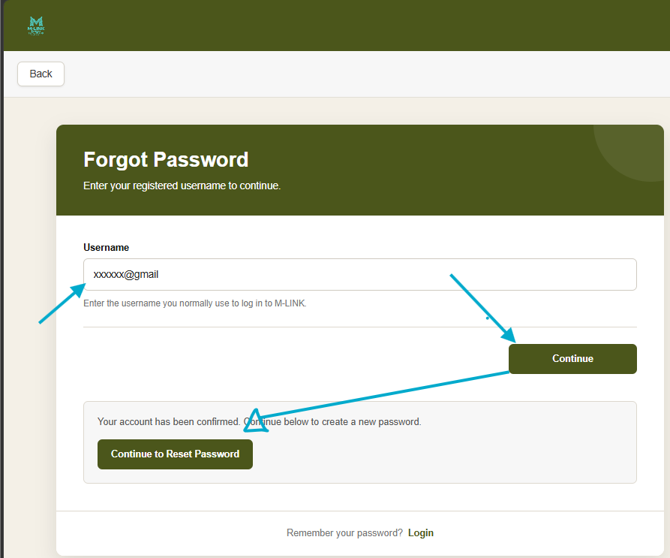
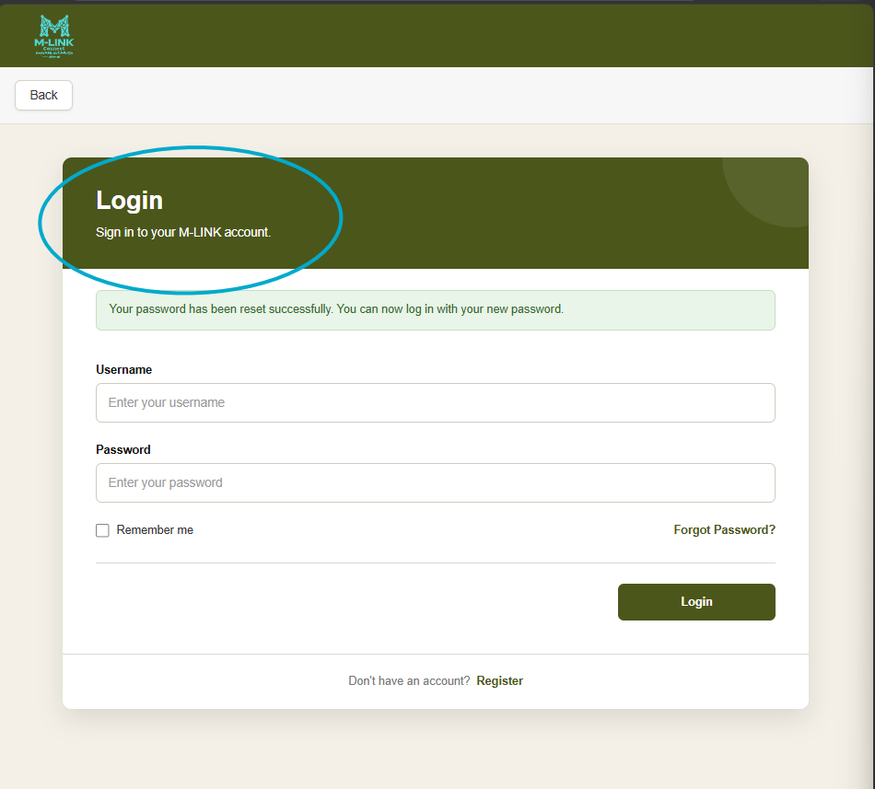
Figure 6: Password reset flow

3 Resident Guide
This section explains the main tasks available to a registered community member.

3.1 Open the resident dashboard
- Log in with a resident account.
- Review the dashboard summary and navigation options.
- Use the menu bar to open ward information, notices, fault reporting, ticket history or profile functions.
Figure 7: Resident dashboard 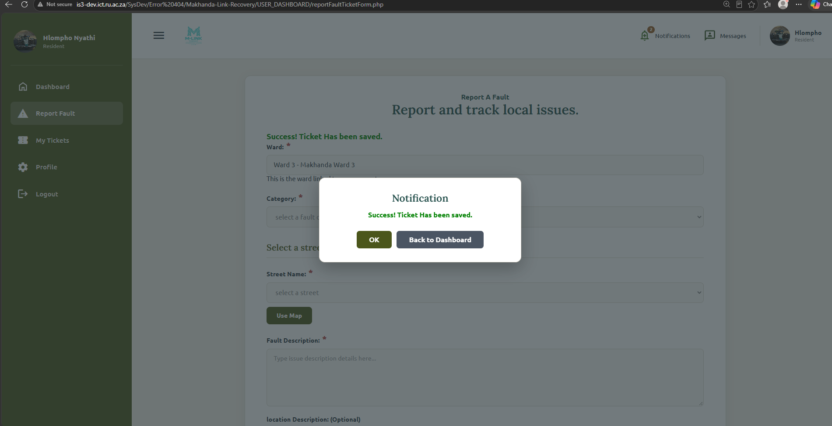
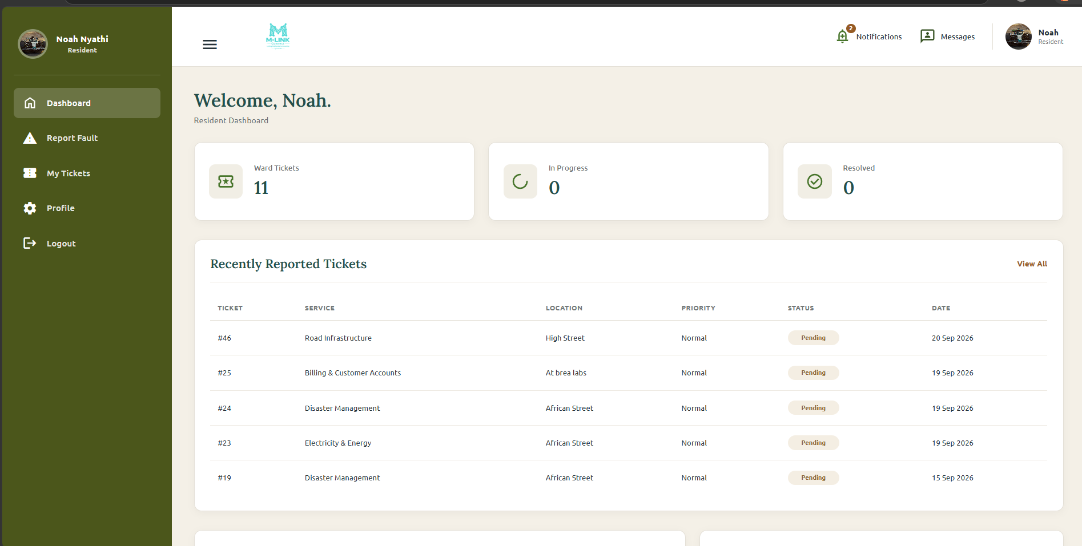

Figure 7: Resident dashboard

3.2 View ward information and notices
- Open the ward or notices area.
- Select a ward.
- Review active notices and their publication or expiry dates.
- Open a notice to read its full description.
Expected result: Current community-wide or ward-specific information is displayed.
Figure 8: Resident notices and ward information
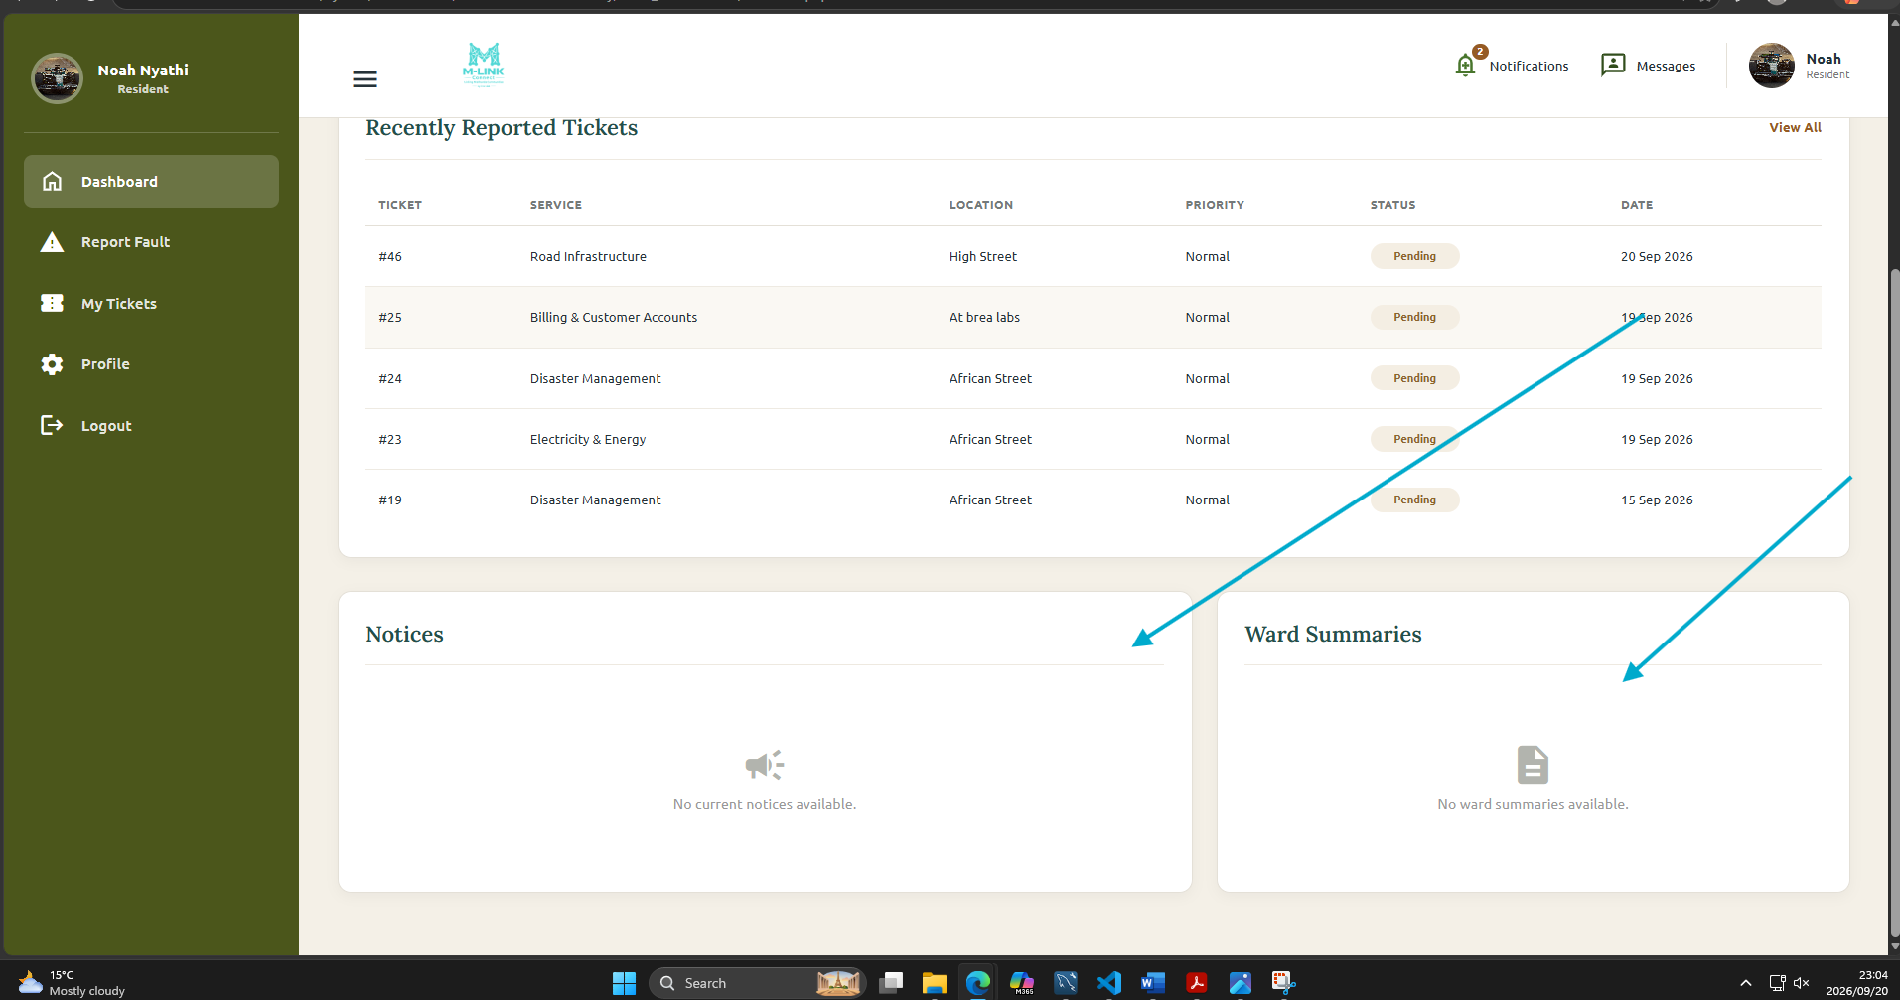
Figure 8: Resident notices and ward information

3.3 Report a service fault
- Select Report a Fault or the equivalent dashboard option.
- Choose the municipal service category.
- Select the ward and address.
- Describe the fault clearly and add the location description.
- The map will show coordinates of where the incident occurred.
- Review the information and submit the report.
Expected result: M-LINK creates an incident ticket and displays its reference or confirmation.
Figure 9: Service fault report form
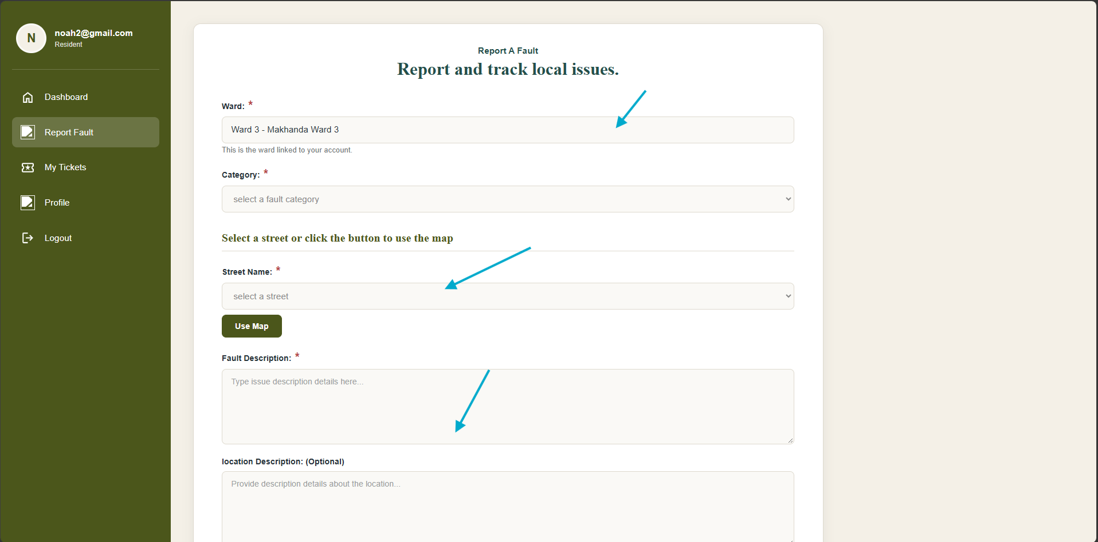
Figure 9: Service fault report form

3.4 Track a reported fault
- Open My Tickets or Ticket History.
- Locate the required ticket by its reference, category or date.
- Open the ticket details.
- Review its priority, status, dates and progress information.
Expected result: The current ticket details and progress are displayed.
Figure 10: Resident ticket history
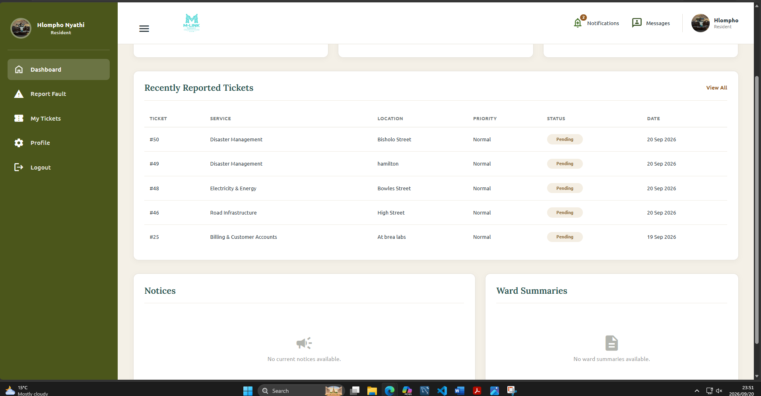
Figure 10: Resident ticket history and progress

3.5 Update the resident profile
- Open Profile.
- Update only the personal information that is allowed to change and your profile picture.
- Enter the current password if confirmation is requested.
- Save the changes.
Expected result: The updated profile information is stored.
Figure 11: Resident profile settings
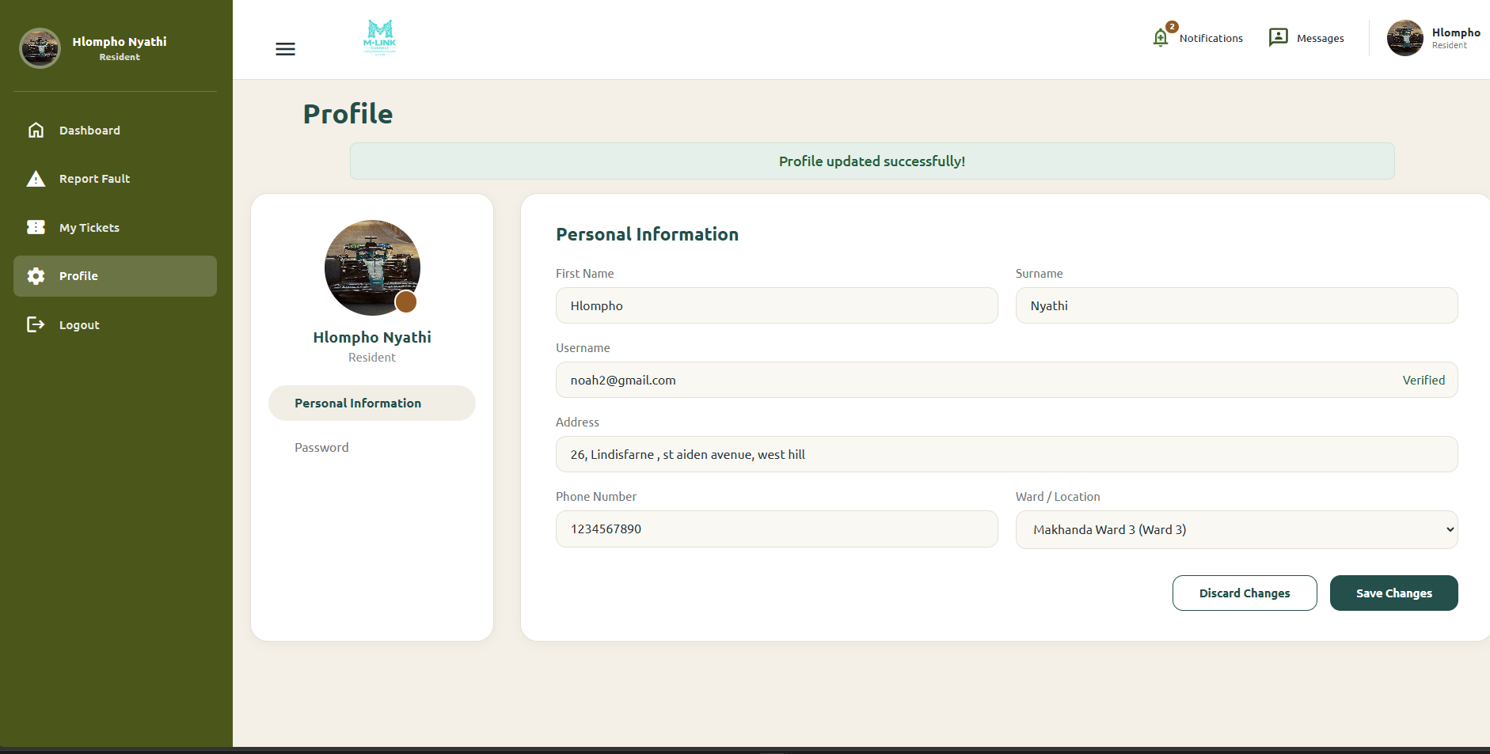
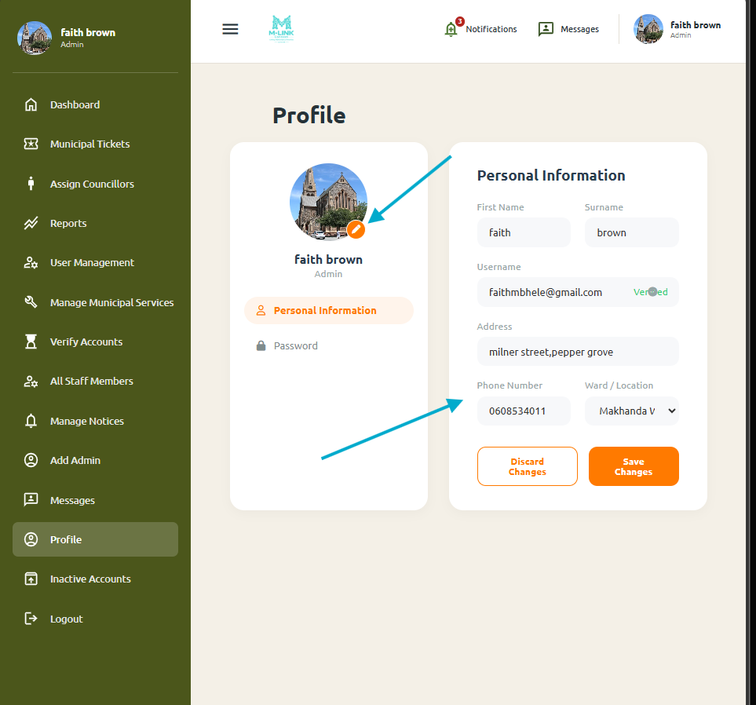
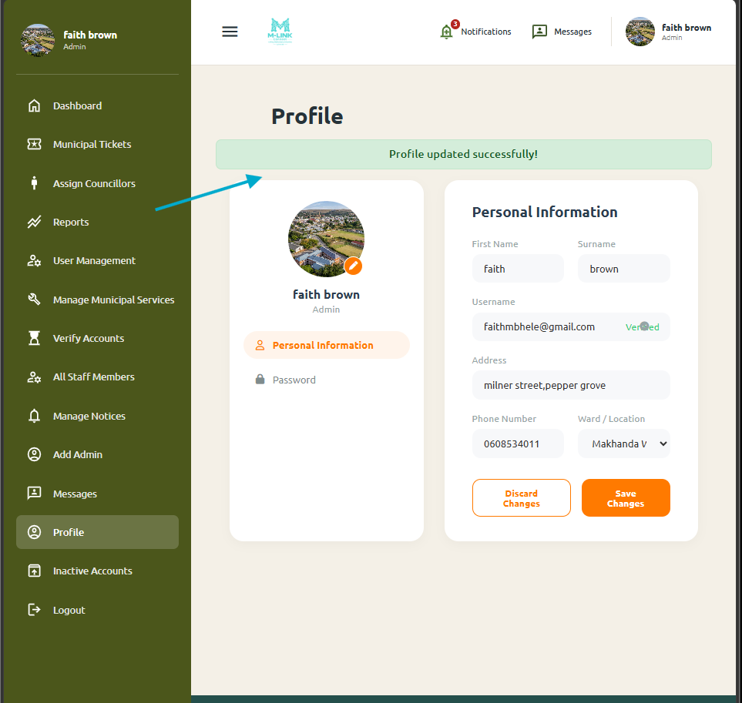
Figure 11: Resident profile settings

4 Ward Councillor Guide
A ward councillor applicant cannot use councillor functions until an administrator assigns the applicant to a vacant ward and activates the account. Only one current councillor may be assigned to each ward.

4.1 Access the councillor dashboard
- Wait for confirmation that the account has been assigned and activated.
- Open the M-LINK login page.
- Enter the councillor username and password.
- Select Login.
- Confirm that the dashboard displays the assigned ward.
Expected result: The ward councillor dashboard opens for the assigned ward.
Figure 12: Ward councillor dashboard
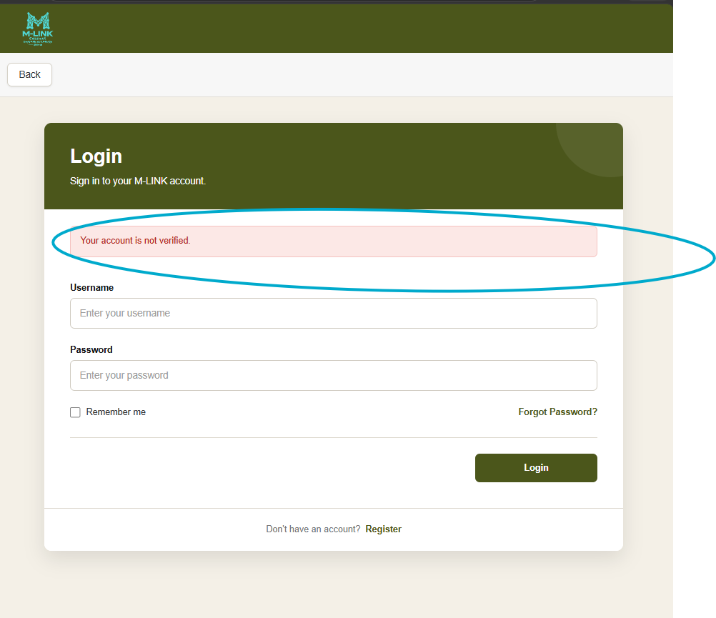
Figure 12: Ward councillor dashboard
Figure 13: Councillor ward information

5 Municipal Staff Guide

5.1 Access the municipal staff dashboard
- Wait for an administrator to verify and activate the staff account.
- Log in using the municipal staff username and password.
- Review the service, division and availability information shown for the account.
Expected result: The municipal staff dashboard opens.
Figure 14: Municipal staff dashboard
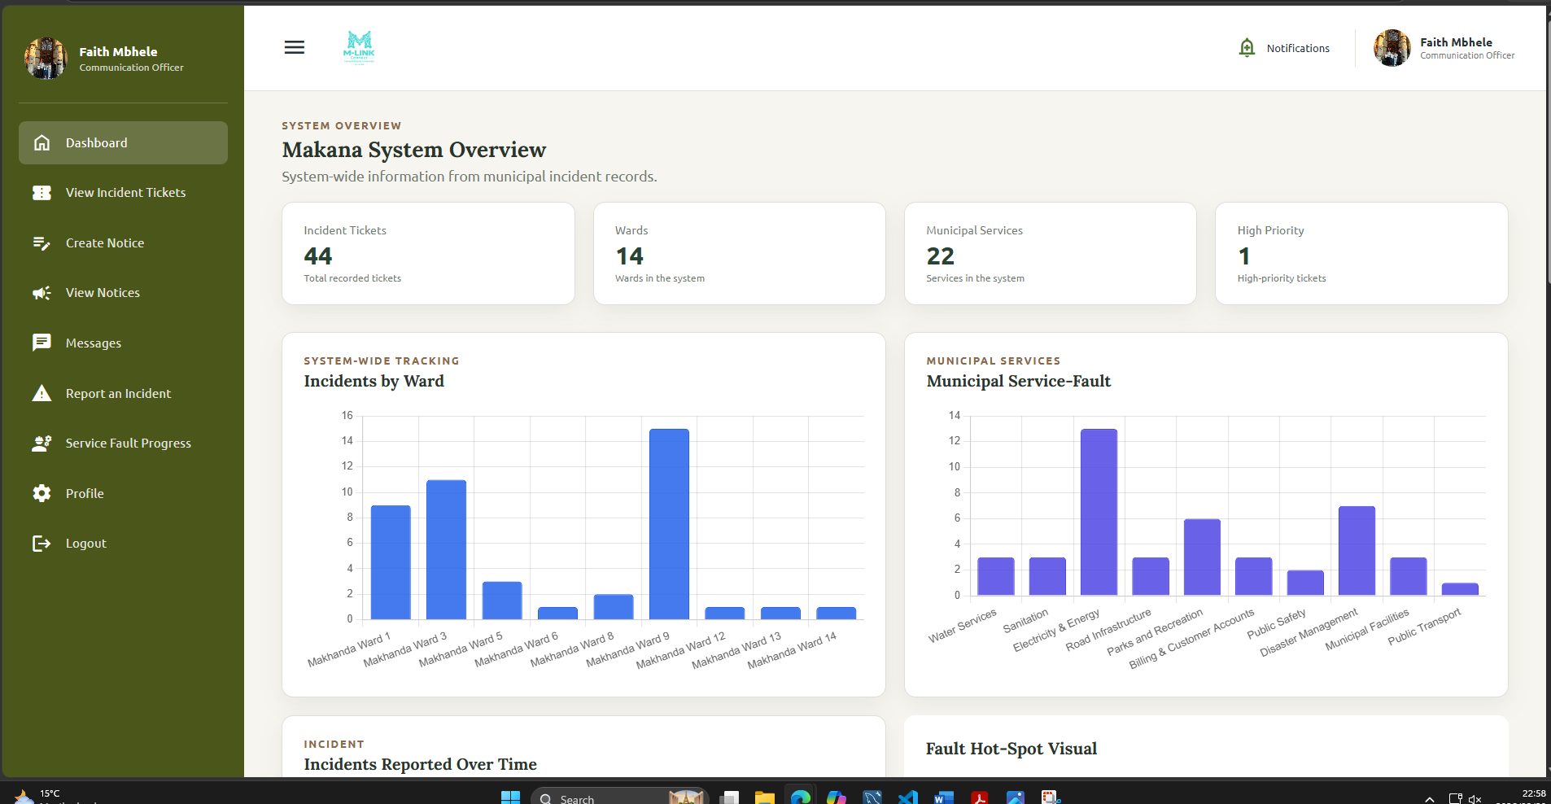
Figure 14: Municipal staff dashboard

5.2 Manage assigned fault tickets
- Open the assigned tickets or service-fault area.
- Use available filters to find the required ticket.
- Open the ticket details and review the fault description, ward, location, priority and current status.
- Update the ticket status or progress using the available action.
- Enter any required resolution information.
- Save the update.
Expected result: The updated ticket status is saved and becomes available in the ticket history.
Figure 15: Municipal staff ticket update
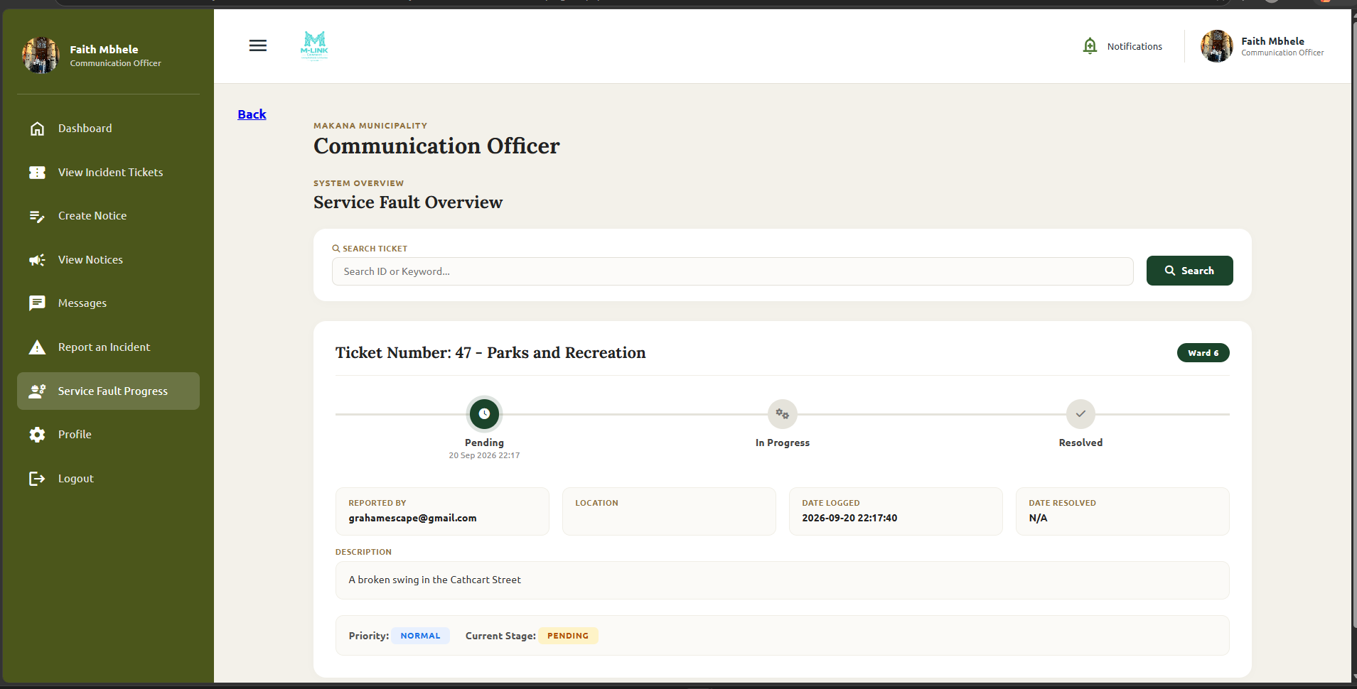
Figure 15: Municipal staff ticket update

6 Organisation Guide

6.1 Access the organisation account
- Complete the separate organisation registration form if an account does not exist.
- Open Login.
- Enter the organisation email address and password.
- Select Login.
- Use the available organisation dashboard functions.
Expected result: The organisation dashboard opens.
Figure 16: Organisation dashboard
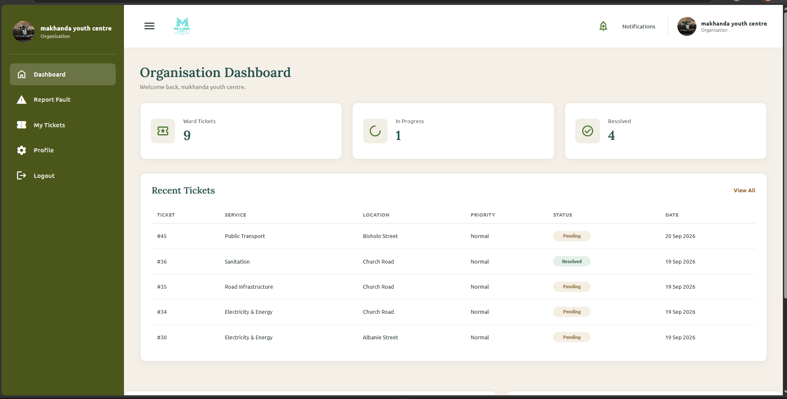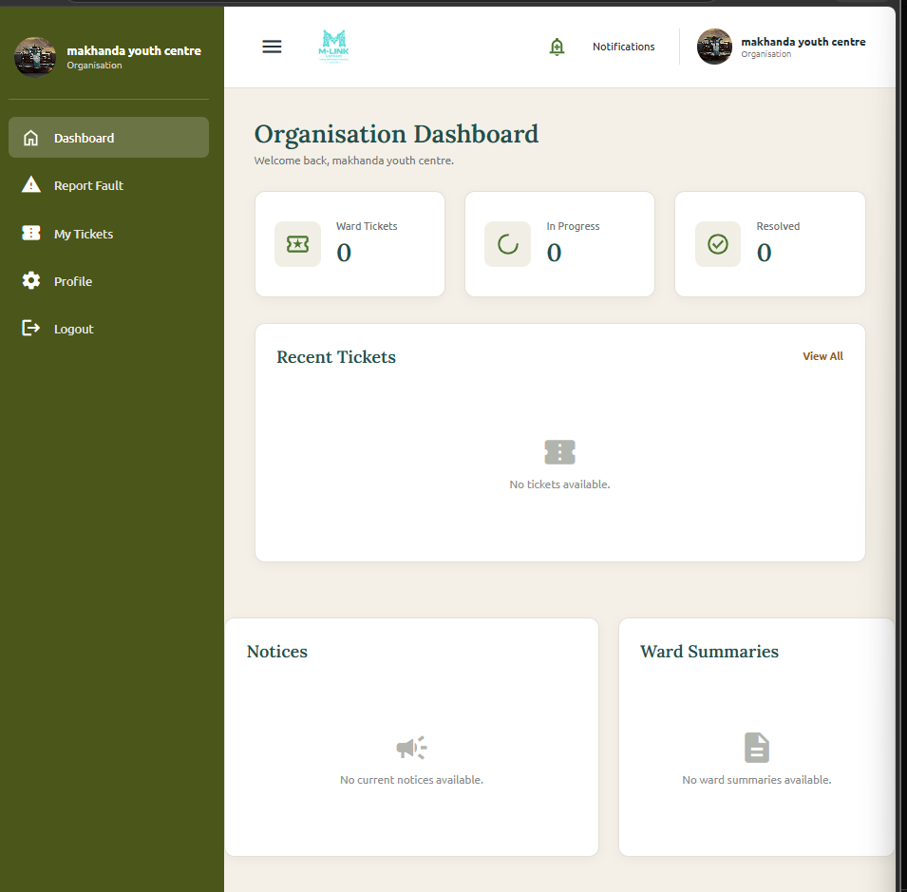
Figure 16: Organisation dashboard

7 Administrator Guide
Administrator functions are restricted to authorised administrator accounts. Actions that change important records may require the administrator password in a confirmation window.

7.1 Use the administrator dashboard
- Log in with an administrator account.
- Review the dashboard counts and recent information.
- Use the sidebar to open the required management page.
- Select the M-LINK logo to take you back to the homepage.
Figure 17: Administrator dashboard
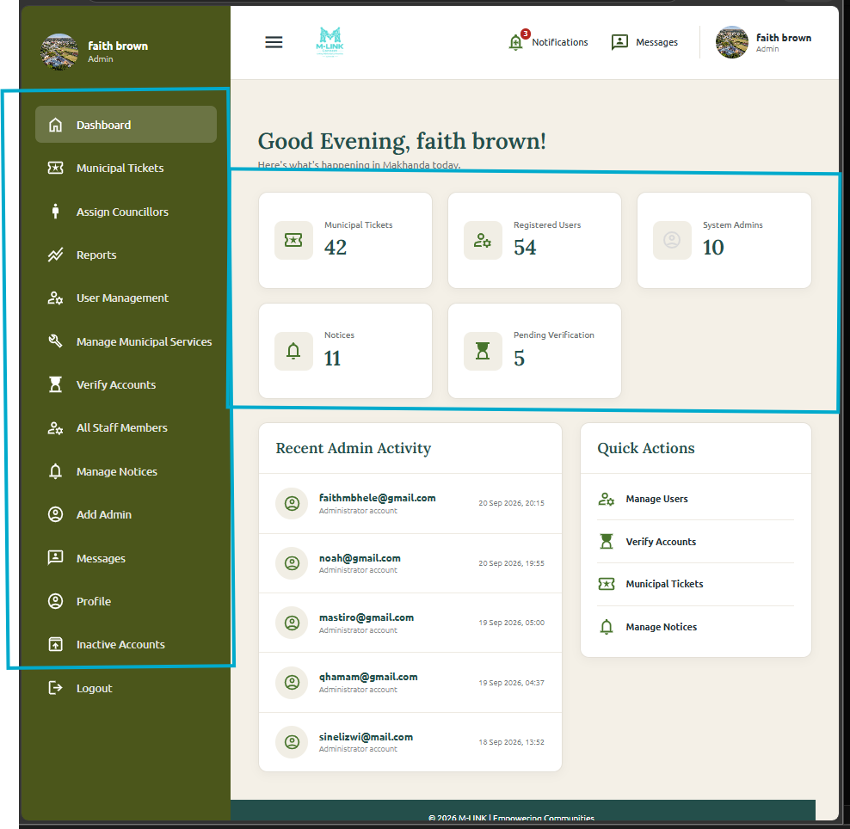
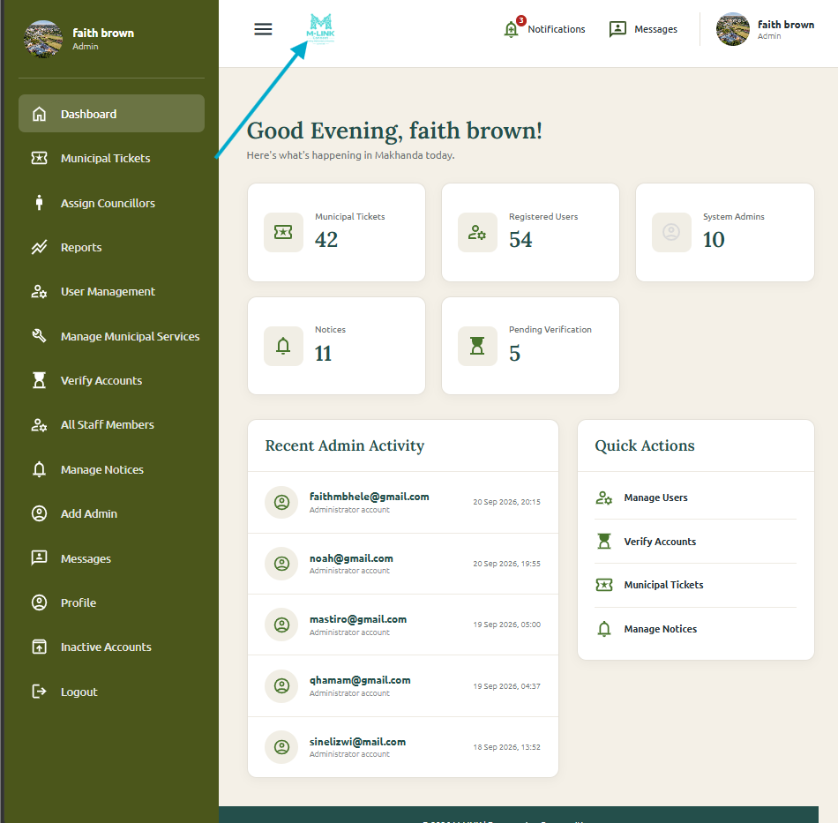
Figure 17: Administrator dashboard

7.2 Verify accounts
- Open Verify Accounts.
- Search for or locate a pending account.
- Review the user's role and details.
- Select Verify or Reject.
- Enter the administrator password in the confirmation window.
- Confirm the action. For a ward councillor, continue through Ward Councillor Assignment instead of direct verification.
Expected result: The selected account is verified and activated, rejected, or routed for councillor assignment.
Figure 18: Verify accounts
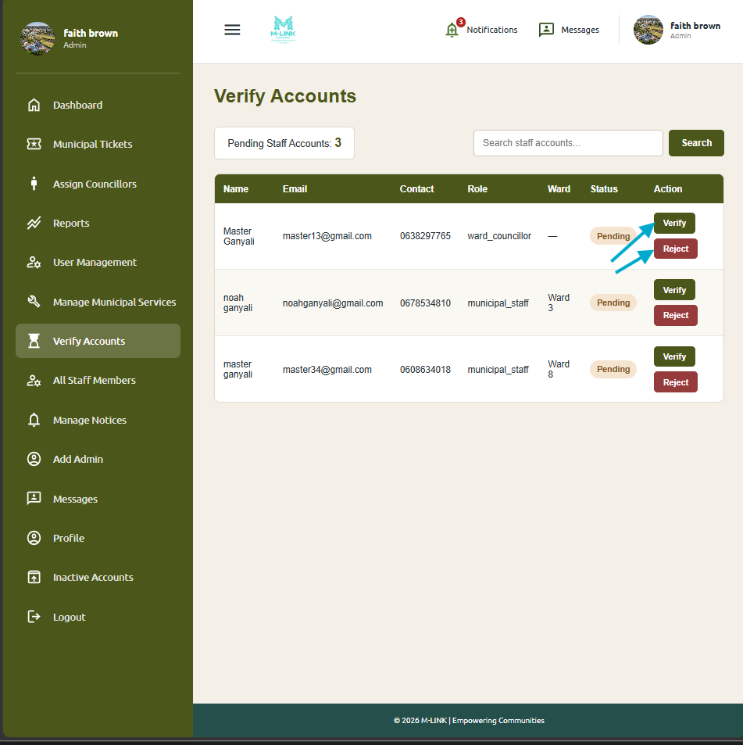
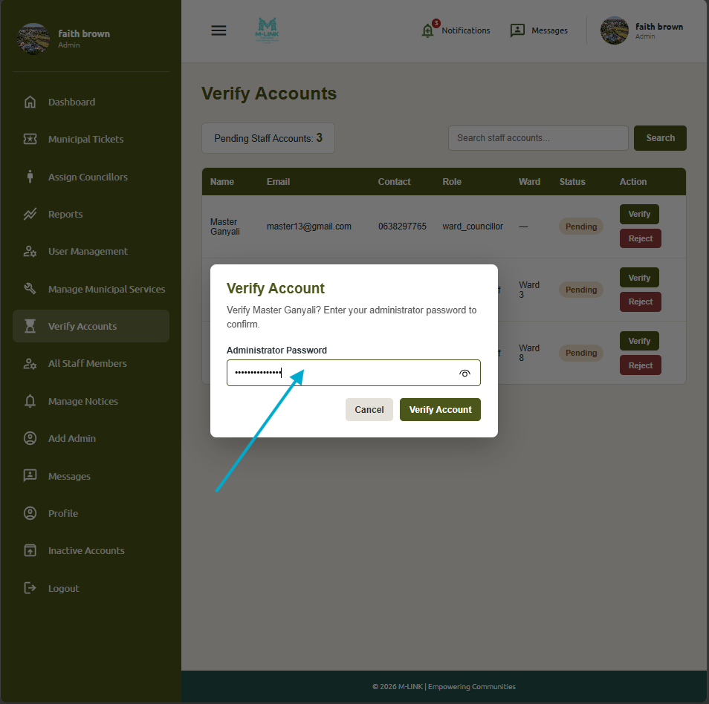
Figure 18: Verify accounts

7.3 Assign a ward councillor
- Open Ward Councillor Management.
- Review all wards and identify a vacant ward.
- Locate the pending councillor applicant.
- Select Assign and choose the vacant ward.
- Enter the administrator password and confirm.
- Use Remove or Restore when managing an existing assignment, following the same password confirmation process.
Expected result: The applicant is assigned, verified and activated only when the ward is vacant. M-LINK prevents more than one current councillor per ward.

7.4 Manage users and inactive accounts
- Open User Management to search for an active user.
- Select the required update or deactivate action.
- Confirm protected actions with the administrator password.
- Open Inactive Accounts to view deleted or rejected accounts.
- Select Restore when an account should be returned to use.
- For a councillor, complete the assignment process before activation.
Expected result: User information or account status is updated without permanently deleting the main user record.
Figure 20: User and inactive-account management
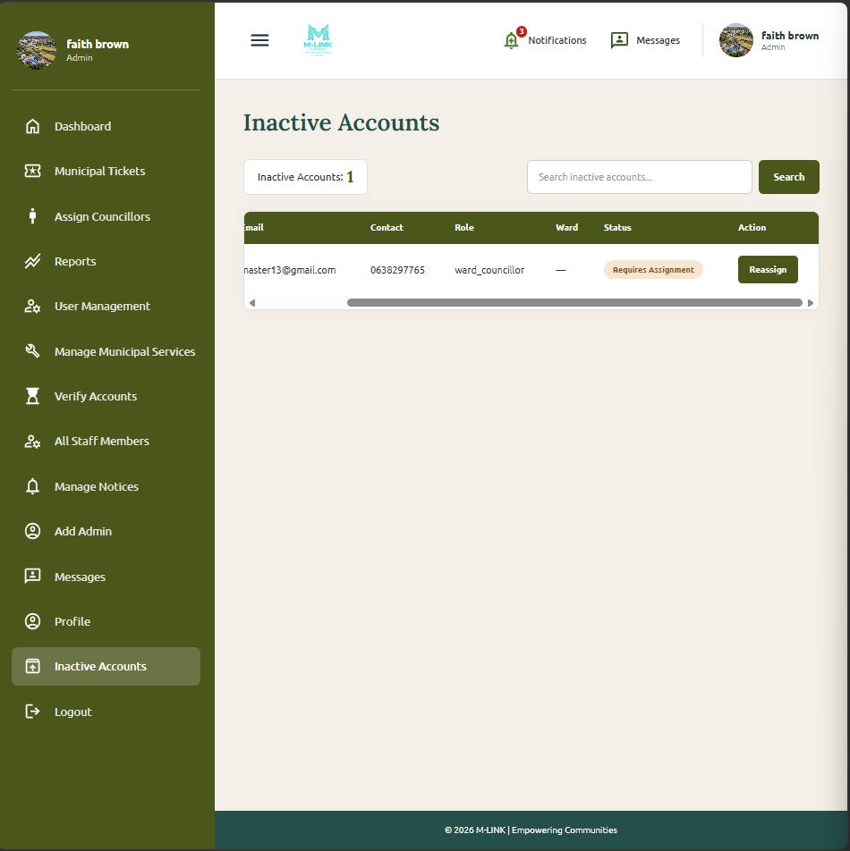
Figure 20: User and inactive-account management

7.5 Manage municipal services
- Open Manage Services.
- Select Add Service to create a service category, or choose Edit for an existing service.
- Enter or correct the service name.
- Save the change.
- Use the drop down to Archive or hide, view current notices, deleted, view old notices and vie All notices.
- Admin is able to create, view and approve all the notices.
Expected result: The service list and active status are updated. Duplicate service names are not accepted.
Figure 21: Municipal service management
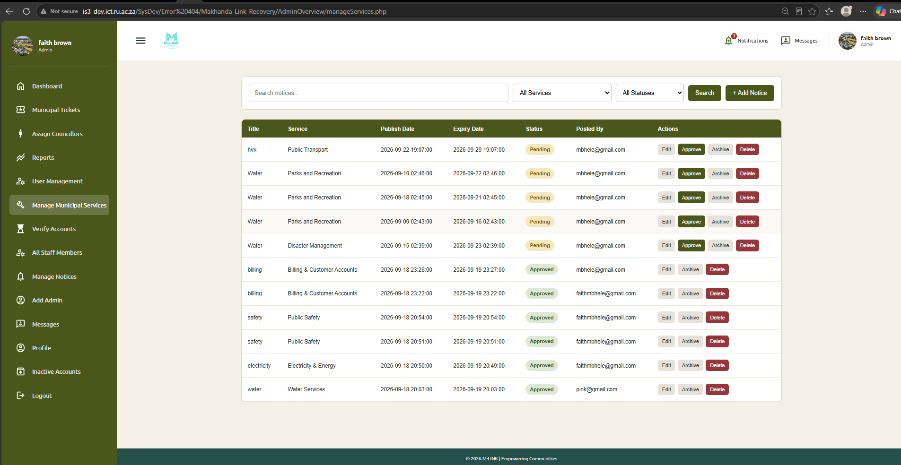
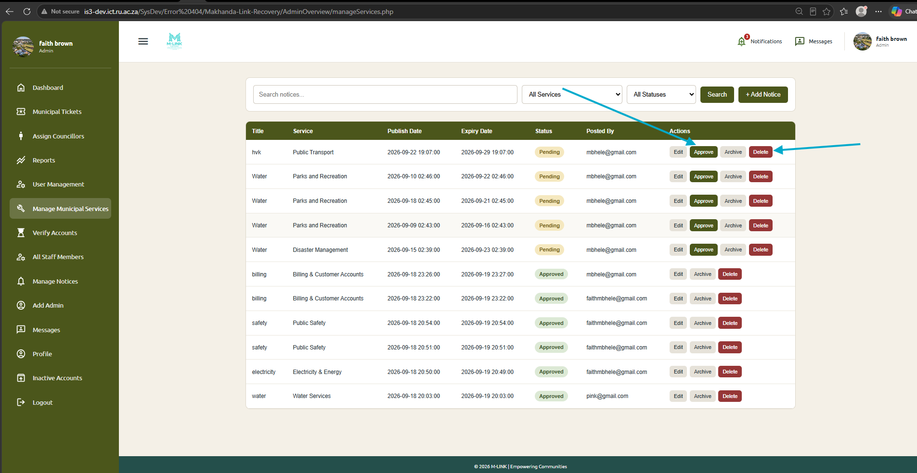

Figure 21: Municipal service management

7.6 Manage notices
- Open Manage Notices.
- Use search, ward and status filters to find a notice, or select Add Notice.
- Enter the title, category, description, publication date and expiry date.
- Choose Community-wide or select one or more wards.
- Save the notice.
- Use Edit, Approve or Delete where appropriate and confirm protected actions with the administrator password.
Expected result: The notice is saved with its selected audience and status. Deleted notices are soft deleted.
Figure 22: Notice management
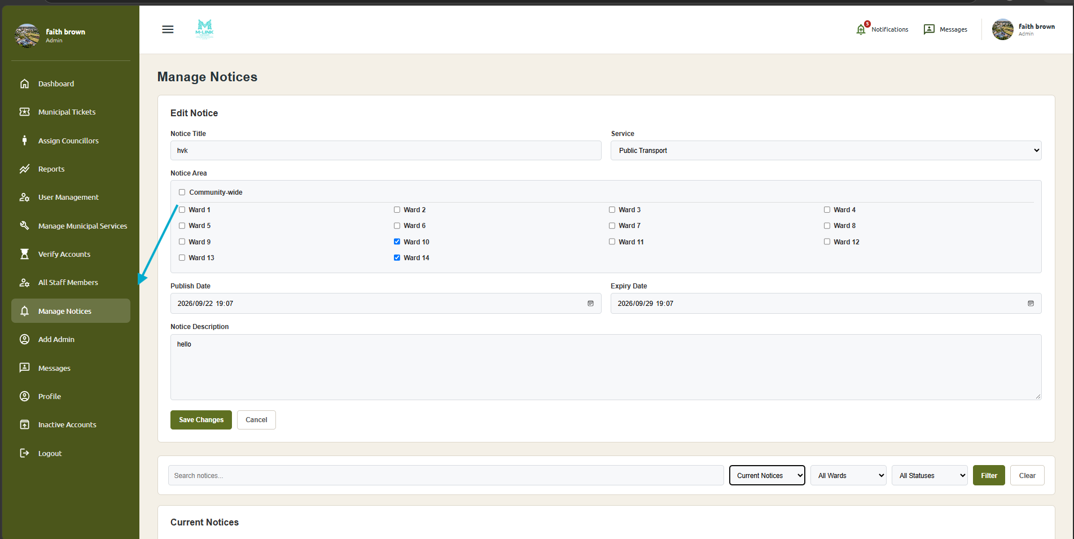
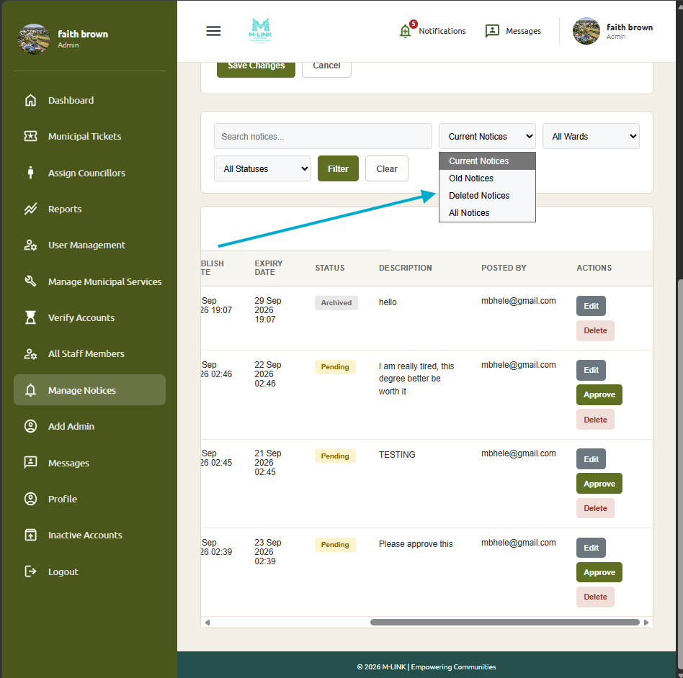
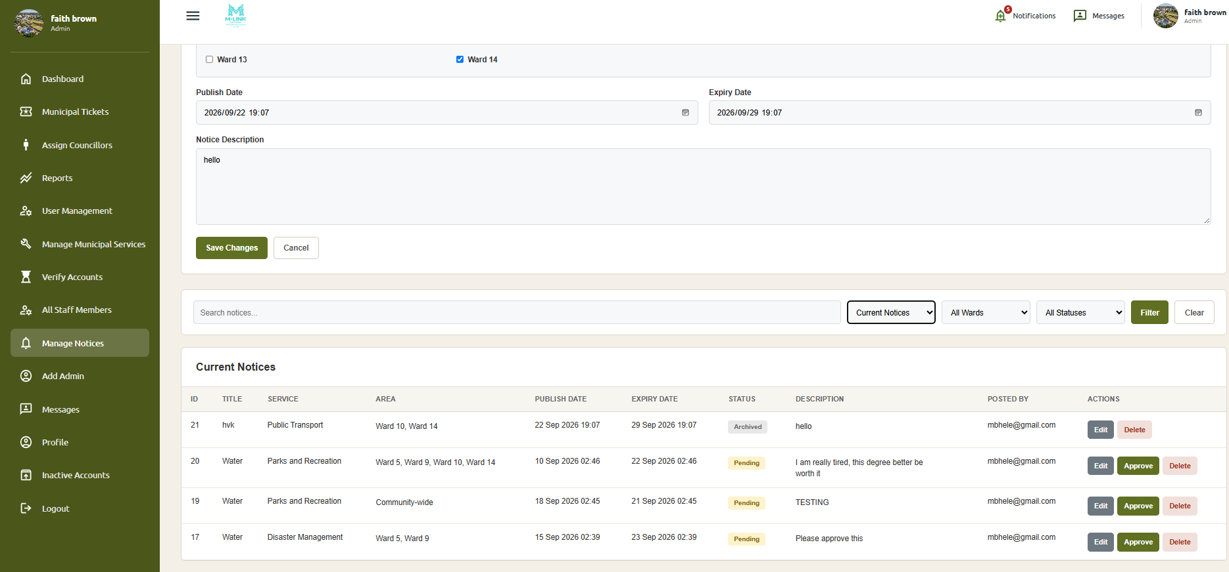
Figure 22: Notice management

7.7 Manage maps and summaries
- Open Manage Wards.
- Select or filter by the required ward.
- Review the ward name, number, map, councillor and summary information.
- Use the available action to update the selected ward information.
- Save the change and confirm that the updated information is displayed.
Expected result: The selected ward's information is updated.

Figure 23: Ward management
Figure 23: Ward management

7.8 Manage and review tickets
- Open Ward Ticket Management.
- Filter tickets by ward, service or priority where available.
- Select a ticket to open its details.
- Review the reporter, category, location, status and dates.
- Open ticket history when earlier progress or status information is needed.
Expected result: The required ticket and its history are displayed.

7.9 View reports
- Open Reports from the administrator sidebar.
- Select the available period, ward, service or category filters.
- Apply the filters.
- Review the displayed service-fault statistics, progress, category history or hotspot information.
- Use the results for monitoring and project reporting.
Expected result: M-LINK displays statistics based on the selected filters.
Figure 25: Administrator reports
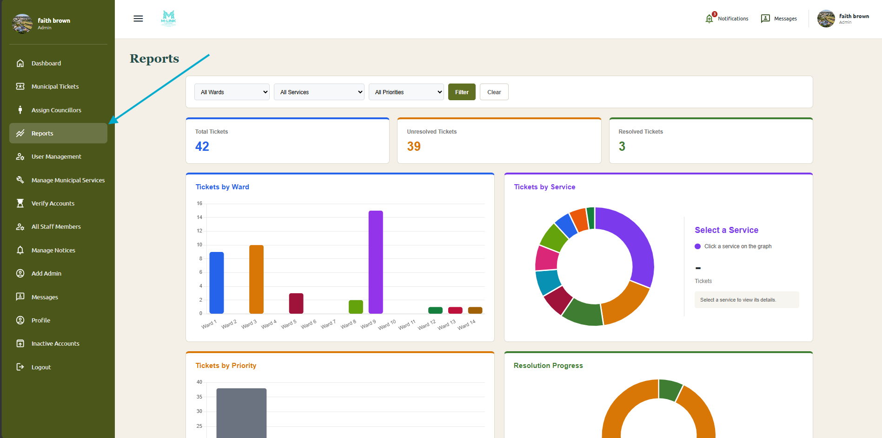
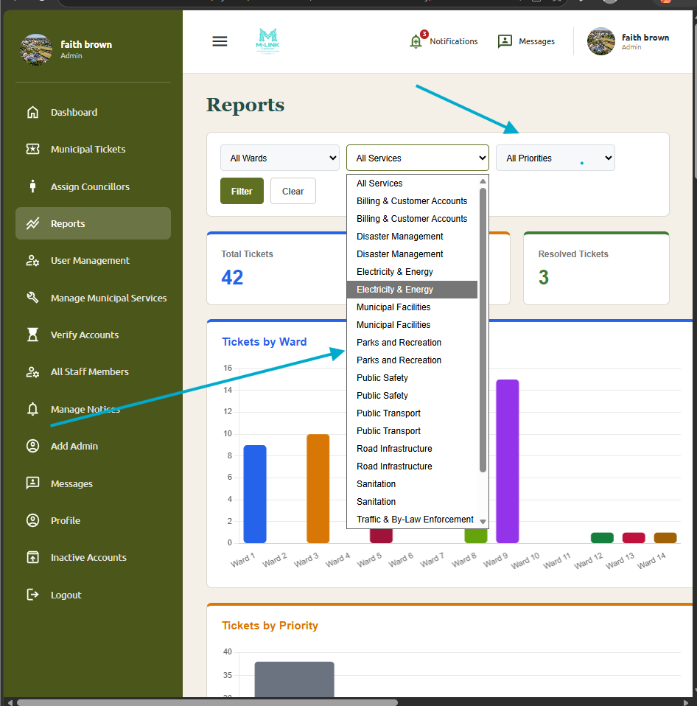
Figure 25: Administrator reports

7.10 Update the administrator profile
- Open Profile or Settings.
- Update the required profile field or profile picture.
- To change the password, enter and confirm the new password as requested.
- Enter the current administrator password in the confirmation window.
- Save the changes.
Expected result: The administrator profile or password is updated.
SCREENSHOT PLACEHOLDER
Figure 26: Administrator profile settings
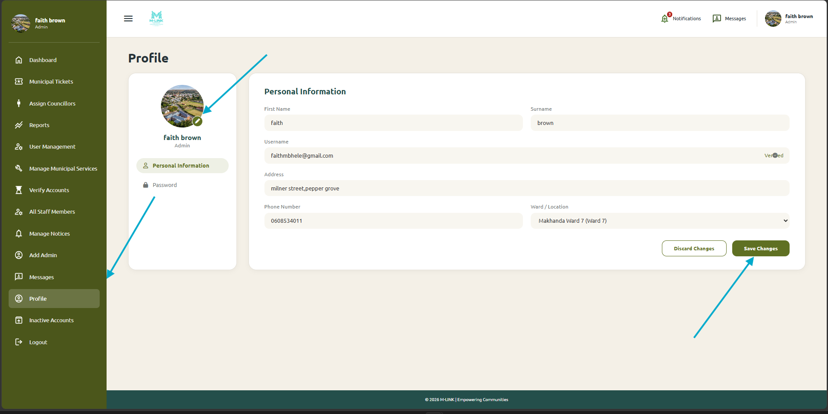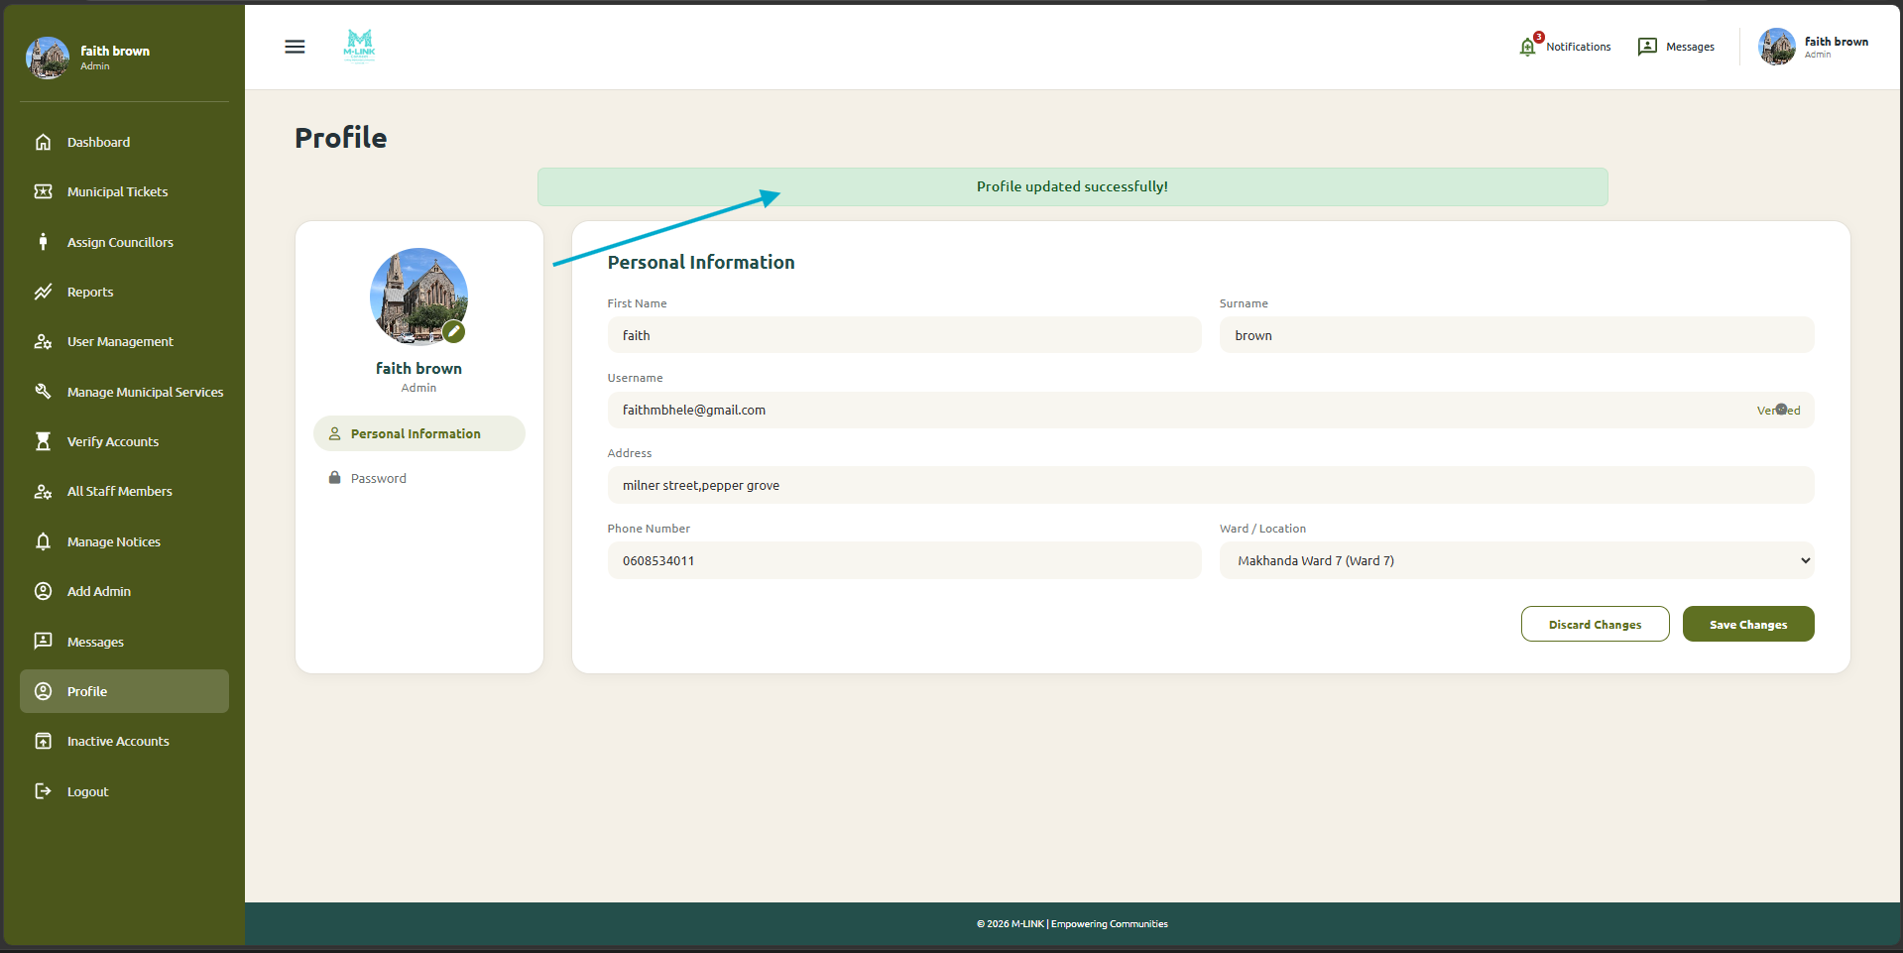
Figure 26: Administrator profile settings

8 Public Information Functions

8.1 View public notices, wards and community information
- Open the public homepage without logging in.
- Scroll to Notices, Explore Your Ward, community issues, weather, dam levels or other public sections.
- Select a ward link to view ward-related information.
- Use the slideshow controls to move through Makhanda facts when required.
Expected result: Public information is available without account access.
Figure 27: Public information sections
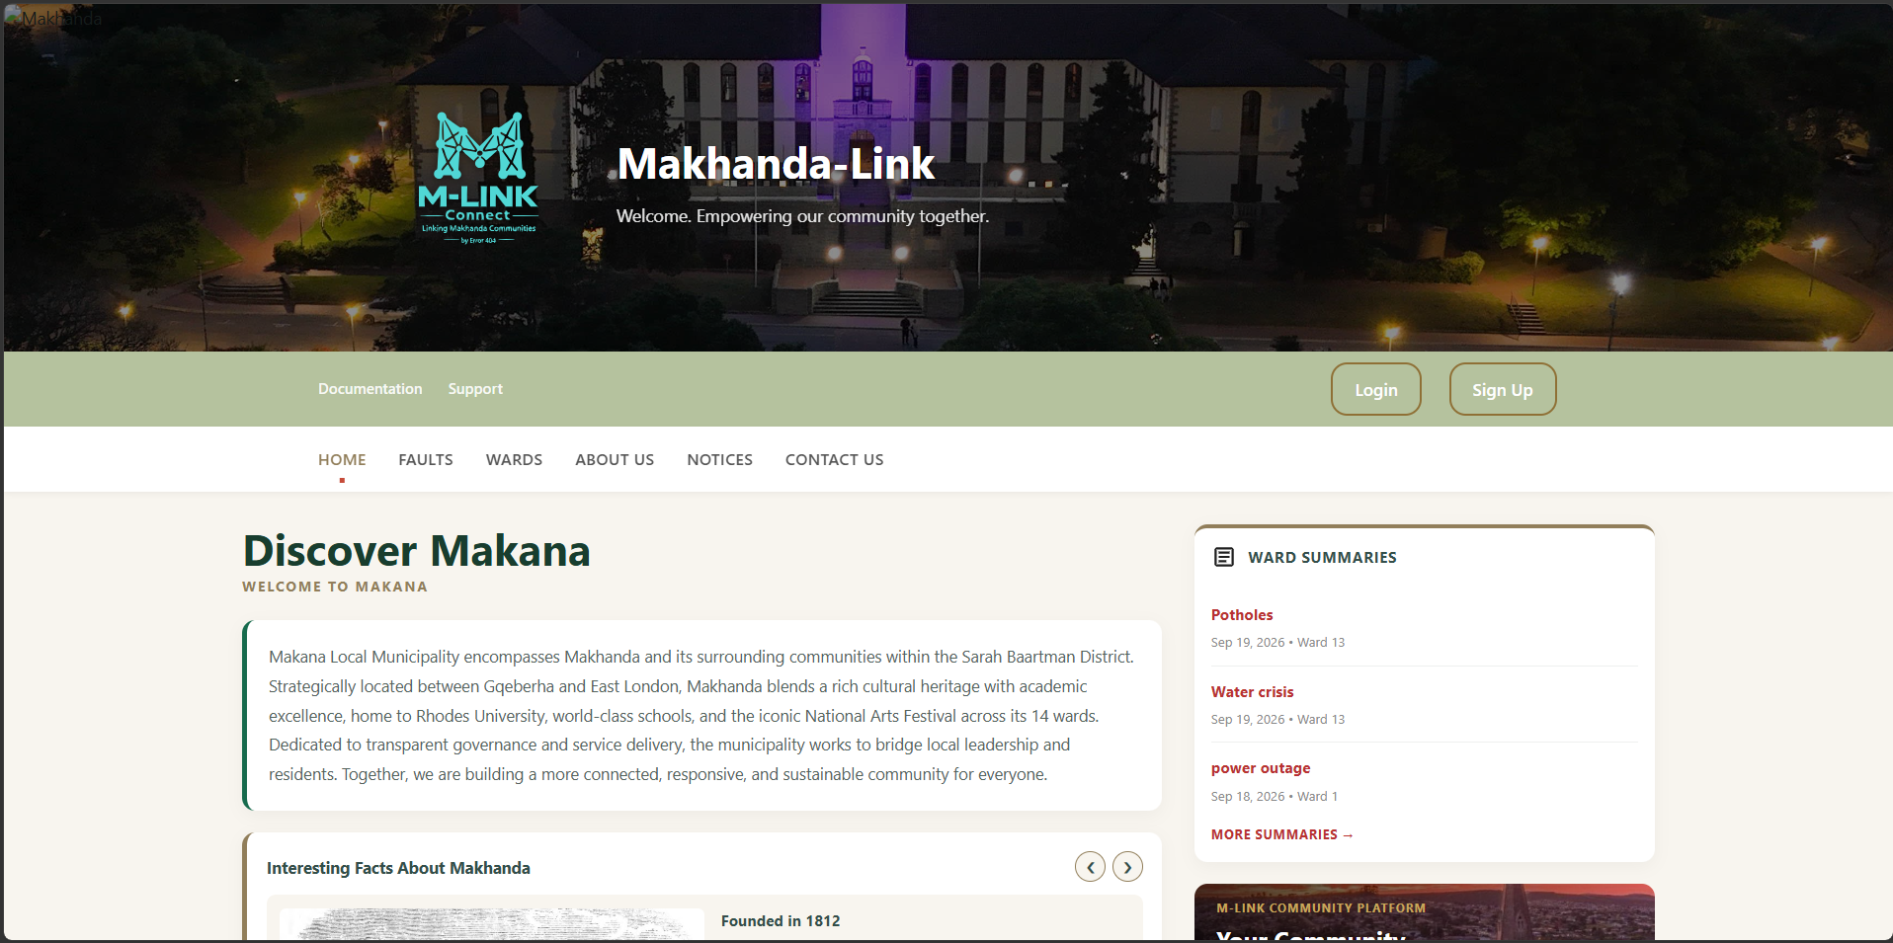
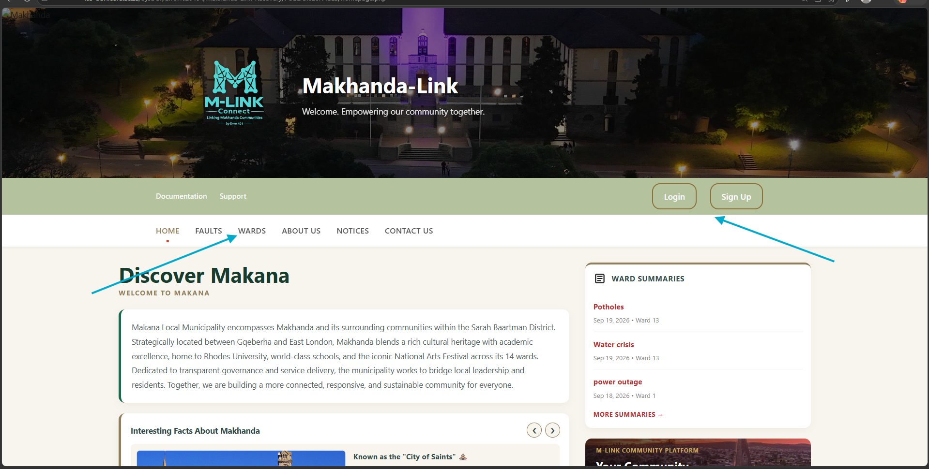
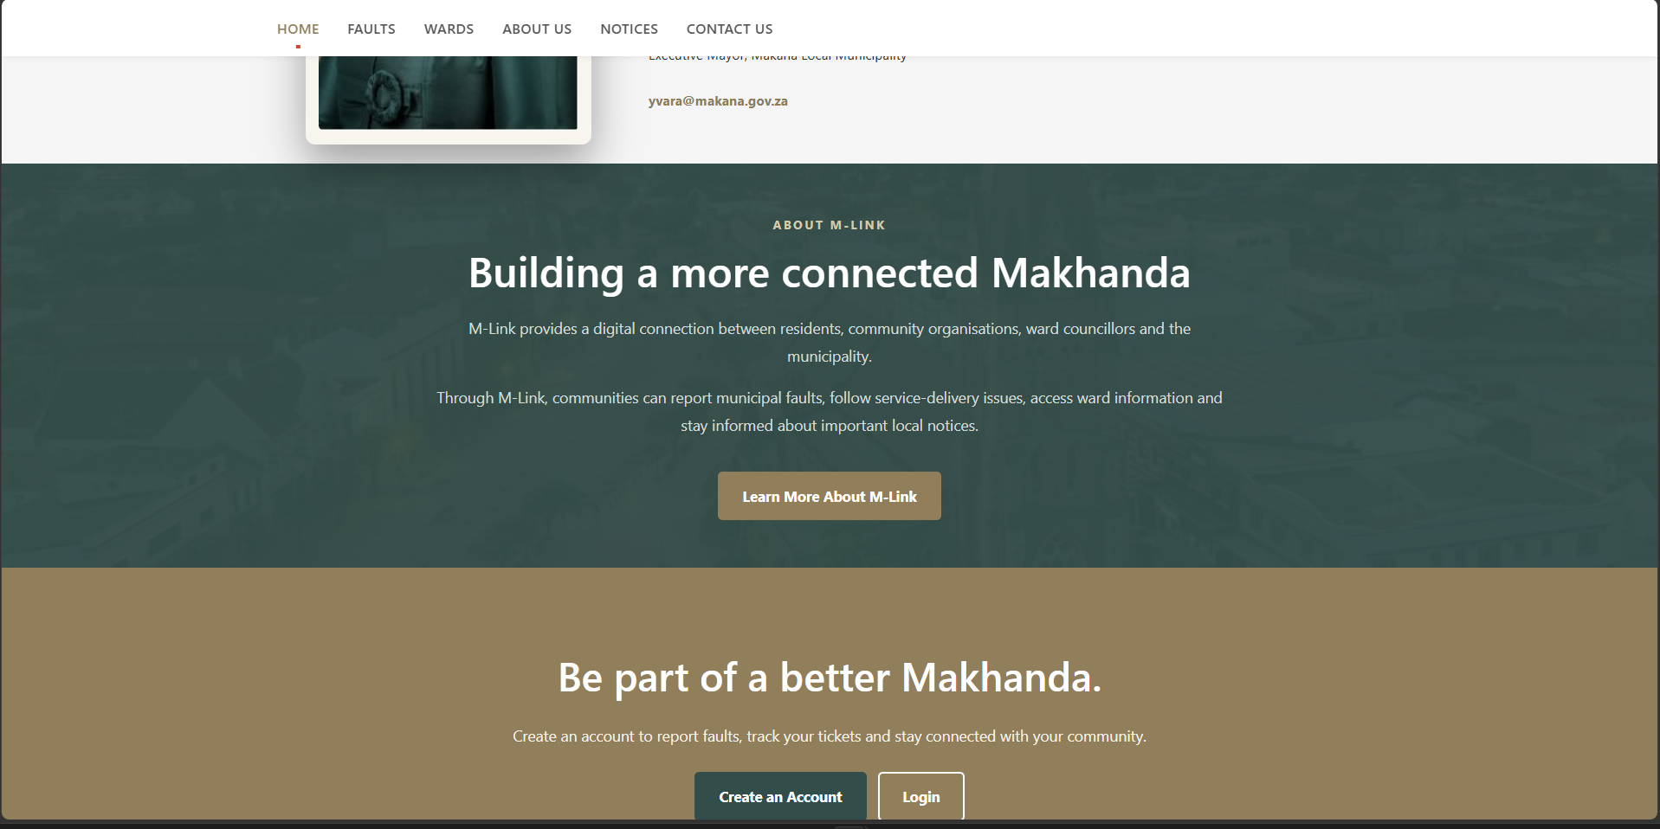
Figure 27: Public information sections

9 Troubleshooting
Problem | Likely reason | What to do
Login fails | Incorrect details or inactive account | Check the username and password. Use Forgot Password if necessary. Staff and councillor users should confirm activation.
One-time PIN fails | PIN expired, incorrect or already used | Request a new PIN and enter it promptly. Do not reuse an earlier PIN.
Page does not load | Connection, server or address problem | Check the internet connection, refresh once, confirm the web address and try again later.
No records appear | Filters are too narrow or test data is missing | Clear the filters, select All where available, and confirm that relevant records exist.
Ward is incorrect | Wrong street or address selected | Return to the form, select the correct street entry and check the automatically filled ward.
Councillor cannot be assigned | The ward already has a current councillor | Remove or reassign the current councillor only when authorised, then assign the applicant to a vacant ward.
Changes do not save | Required fields, dates or password confirmation are invalid | Review the on-screen message, correct the highlighted information and submit again.
Figure 28: Example error or validation message

10 Security and Logging Out
- Do not share passwords or one-time PINs.
- Use a strong password that is not reused on another account.
- Check information before submitting or approving an action.
- Do not leave an administrator or staff session open on a shared computer.
- Select Logout when finished.
- Close the browser if the device is shared.
Expected result: The session ends and the user returns to a public or login page.

Document control
Document | M-LINK Help and User Guide
Version | 1.0
System | Makhanda Connect System
Status | Draft for screenshot insertion and final review

